Investigative Assessment Report
Jonathan Wayne Scully
&
Kerstin Bonicard Scully

Subjects of this investigation:
- Jonathan Wayne Scully (DOB: 04/11/1992)
- Kerstin Bonicard Scully (DOB: 04/1992)

BLUF:
The information summarized in this report supports the conclusion that Jonathan Wayne Scully presents recurring indicators of financial irresponsibility, opportunism, weakened corporate governance, and possibly criminality in the operation and handling of business affairs. As reflected in the report, his public rhetoric, entity history, and the Pelican Companies’ litigation chronology collectively indicate that his pursuit of money and expansion repeatedly outpaced disciplined financial stewardship and responsible corporate management, resulting in entity instability, compliance issues, control failures, allegations of misuse of business assets, removal from management, litigation over ownership and control, and a court order prohibiting him from exercising control over company property pending arbitration.
This pattern is further reinforced by his personal financial conduct during periods of documented financial distress. While Pelican Companies faced escalating liabilities, reported tax deficiencies, and a condition in which liabilities exceeded assets by approximately $5 million, Scully’s household acquired a $422,000 residence—later transferred solely into his name. In October 2025, Kerstin publicly displayed the purchase of a 2025 Lexus TX 350 valued between approximately $56,000 and $70,000. These acquisitions, occurring alongside allegations of unpaid taxes, misuse of company funds, unauthorized asset sales, and diversion of proceeds, reflect a clear pattern of prioritizing personal asset accumulation over fiduciary responsibility and lawful financial management.

Key Findings

1. Money fixation and absolutist ambition are persistent themes in Scully’s own public communications.
Scully’s self-authored rhetoric repeated over years rather than a single isolated line. The recurring themes are money, scale, luxury, status, and urgency.



2. The hurricane/BP-spill rhetoric supports an opportunistic and morally detached view of catastrophe.
- April 4, 2016 - Jonathan Scully created Pelican Contractors of USA llc and Pelican Companies of America llc in 2019. With home repairs services going back as far as 2012 with Complete Contracting Services llc., these companies would benefit from natural disasters.
  - Pelican was approached by Lamar Contractors and Excel USA to work in the United States Virgin Islands (USVI) after Hurricanes Irma and Maria. The work was part of the STEP program and Pelican completed construction orders on more than 300 homes across three islands.
- Comments made by Scully points to a character orientation in which other people’s loss can be reframed as a chance for personal or business gain. This rhetoric and clear-cut opportunism will not bode well for Scully should he ever be prosecuted and tried in front of a Louisiana Jury in particular.
  - 
  - 
  - October 7, 2020 - A news article was found mentioning members of Pelican Companies boarding up windows of MC Bank in Amelia, LA in preparation for Hurricane Delta. This strengthens the argument that Scully stands to benefit from natural disasters.
    - 

3. The business-record set shows entity churn, instability, and weakening corporate hygiene.
The Louisiana Secretary of State records reflect a broad business footprint with several inactive entities and at least one active entity that was not in good standing.

Significance: This identifies a larger entity pattern with multiple dissolved or inactive businesses, ownership changes, and at least one compliance lapse in an active company. That is consistent with operational strain and weakened controls.

4. Pelican Companies is the strongest example of financial strain, governance breakdown, and alleged self-benefit conduct.
The Pelican Companies timeline shows a progression from promised expansion capital to contested ownership, then to equipment-financing strain, accusations regarding taxes and personal charges, removal from management, and court restrictions on Scully’s control.

Timeline of events for litigation involving Pelican Companies

Scully’s Linkedin post regarding the above litigation.
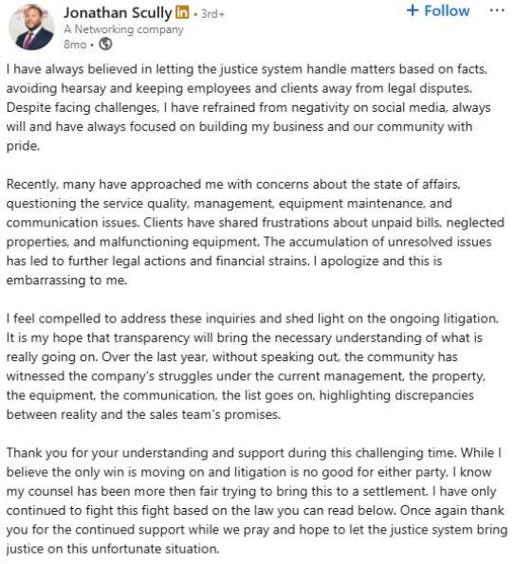

Other legal findings

2018 Arrest - Unconfirmed charges
- 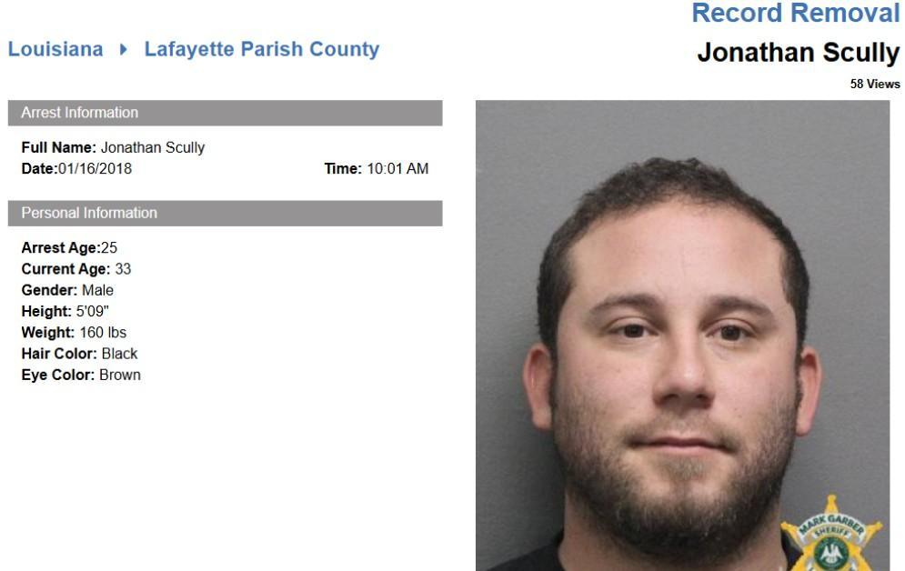

- Details about this civil case involving Scully/Pelican Contractors were not identified.
  - 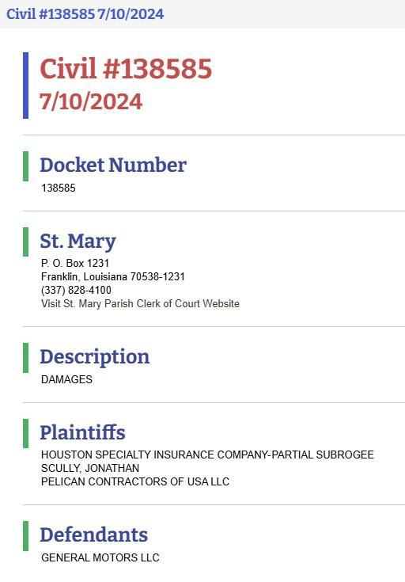

Business findings for current businesses:
Scully is listed as Manager/Registered Agent

I & M Company
  - No website, business description or public facing digital footprint was found for this business.
  - 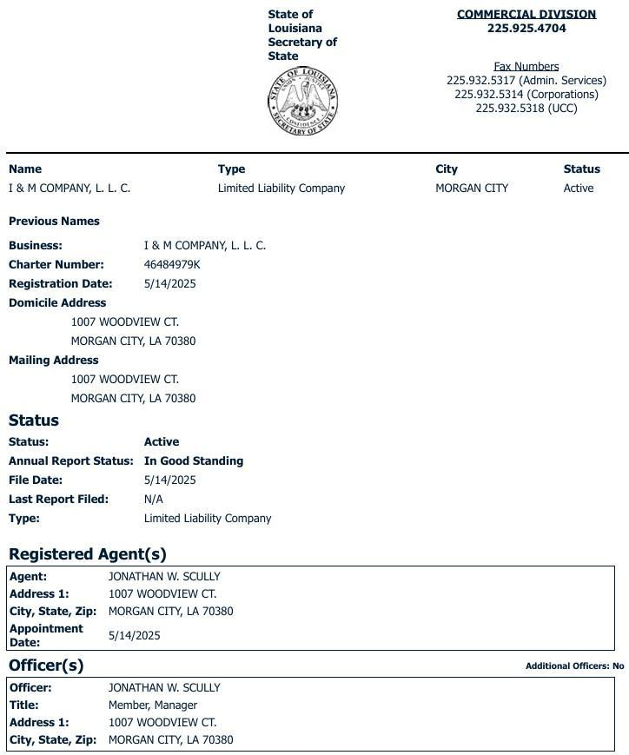

Louisiana Thermal & Night Vision:
https://louisianathermal.com/
  - 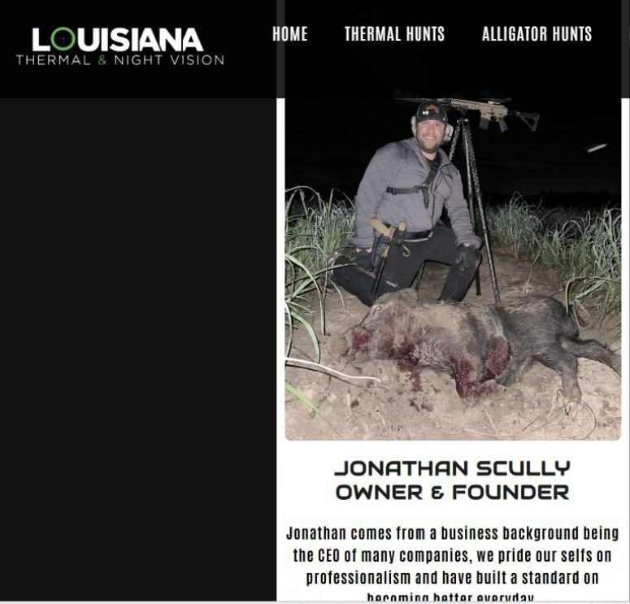
  - 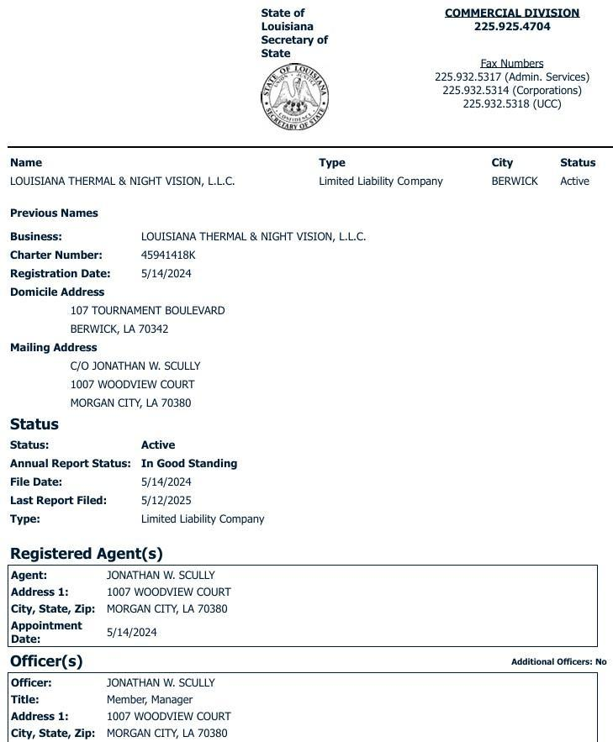

- Pelican Energy Solutions of America
  - No website, business description or public facing digital footprint was found for this business.
  - 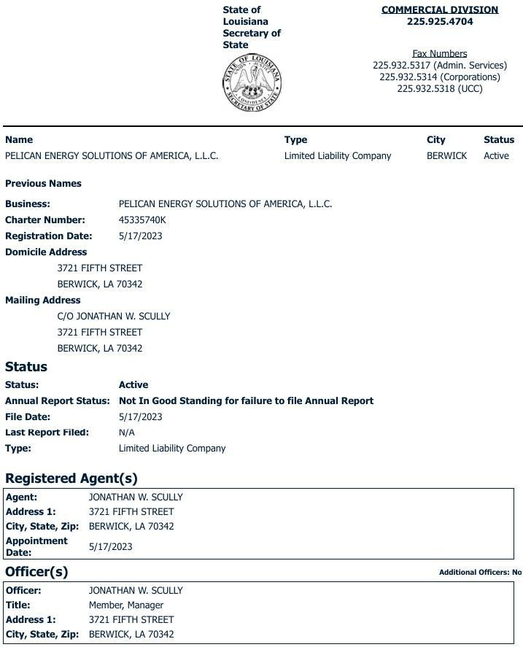

Assets:
Residence:
Address: 1007 Woodview Dr Morgan City, LA 70380
- This address appears to be the primary residence for Jon and Kerstin Scully. This property was purchased by Kerstin Bonicard for $422,000 on October 30th, 2024. John Scully’s name appears to be added to the deed on a later date. On November, 19th, 2024 an Interfamily transfer occurred listing Kerstin Bonicard as the seller and Jonathan Scully as the sole owner.
  - 
  - 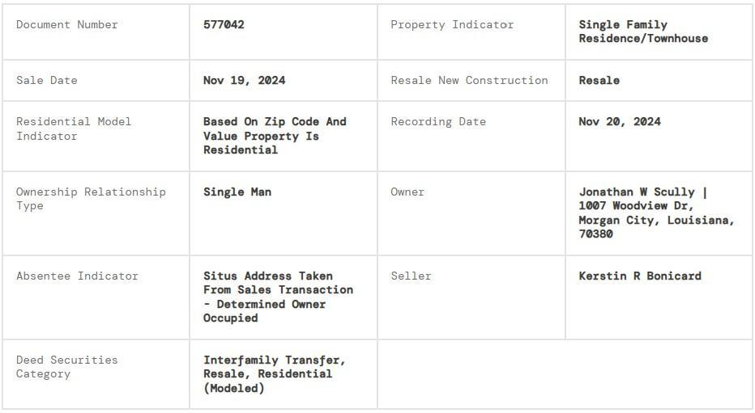

Vehicles:
No vehicle ownership was identified for Jonathan Scully. However, Kerstin Scully appears in an October 2025 photograph with a newly purchased vehicle, as documented on her Instagram account. Photo provided under Kerstin’s social media/Instagram findings.

Social Media Findings for Jonathan Scully:
Using the initial data point of Scully’s phone number (985-519-7124) the below accounts were discovered. An email was later revealed, jon_wayne_scully@yahoo.com, which helped strengthen the identified accounts below.

Linkedin
  - Scully still represents himself as being the President/CEO of Pelican Companies of America and the president of Pelican contractors of USA. As a result of the Pelican Companies Litigation, Scully is no longer involved in these companies. Scully is still actively posting to this Linkedin account, but the posts pertain to updates about his new business, Louisiana Thermal & Night Vision.
  - 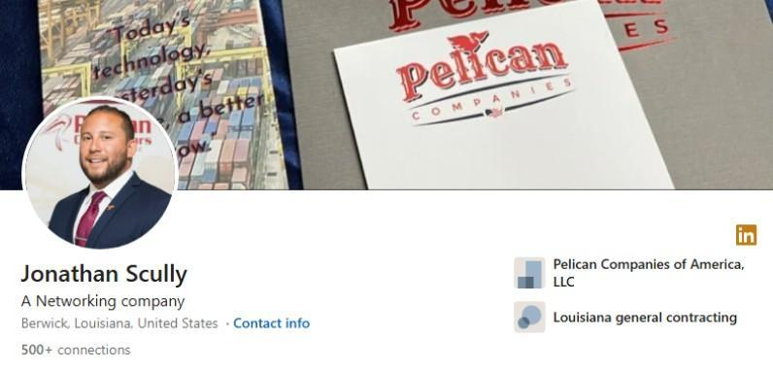
  - 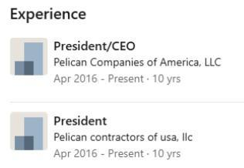
  - 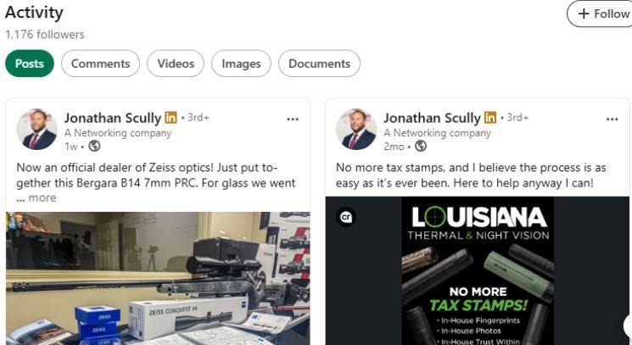

2nd Linkedin account
  - No posts have been made to this account.
  - 
  - 

3rd Linkedin account
  - No visible posts. Historical account
  - 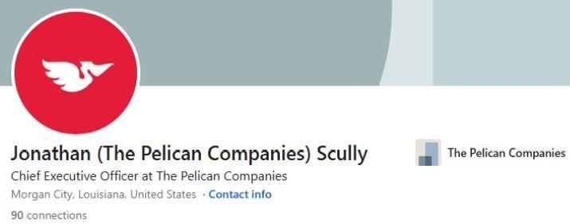
  - 

Facebook:The identified Facebook accounts below for Jonathan and Kerstin, along with 55 associated friend and family accounts, were analyzed using investigative tools to identify current and historical marketplace listings potentially involving items from job sites or the rental property at 107 Tournament Blvd. No relevant listings were identified within the timeframe of interest. Given Scully’s involvement in the construction industry, such items could be disposed of through non-public channels without requiring online postings.

  - No information relevant to this investigation was identified on this account.
    - 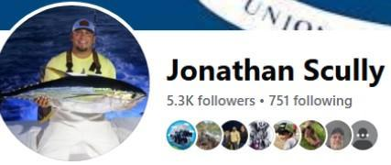
  - A historical listing for generators, dated approximately nine years prior, was identified; however, it falls outside the relevant timeframe of this investigation.
    - 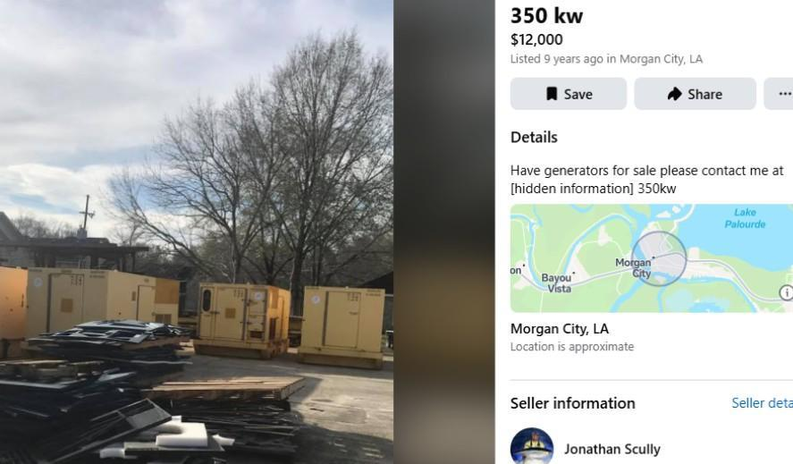

2nd Facebook account:
  - No posts were found on this account
    - 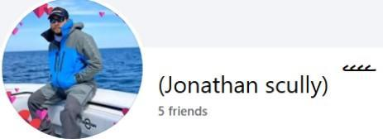

Instagram:
  - No information relevant to this investigation was identified on this account.
    - 
      - The Threads account provided in this Instagram account is private.
      - Link to Scully’s new Thermal & Night Vision business provided.

X:
  - Historical account. The last post was made on May 16th, 2014
    - 
    - 
    - 
    - 
2nd X account
  - Historical account. The last post was made on Sept. 26th, 2022. This account is the source of the comments referenced in Sections 1 and 2. Additional comments from Scully have been added to this section to further show his financial opportunism and character.
    - 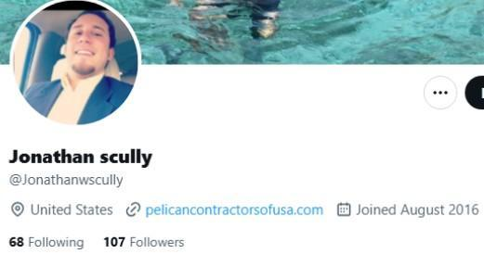
    - 
    - 
    - 
    - 
    - 
    - 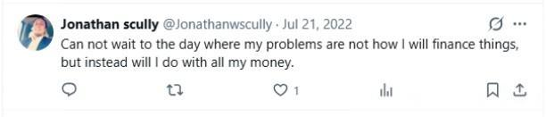

Social Media Findings for Kerstin Scully
Using the initial data point of Kerstin’s phone number (504-252-6710) the below accounts were discovered. An email was later revealed, kerstinfamiglio@gmail.com, which helped strengthen the identification of the below accounts.
Linkedin
  - Current employment: Hyatt Regency in New Orleans as “Major Market Group Sales Manager”.
    - 
    - Previous employment worth noting: Legal Assistant - Carl Finley, Attorney-at-Law, L.C in Metairie, LA. February 2013 - March 2014

Facebook
  - No information relevant to this investigation was identified on this account.
    - 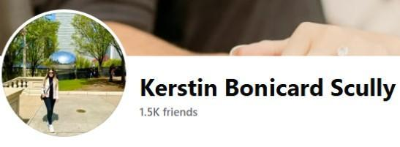

TikTok
  - No content posted to this account
    - 
Instagram
  - Oct. 27th, 2025 - Kerstin appears to post a photo of a new vehicle purchase. The same vehicle photo is posted on the linked Threads account. This vehicle appears to be a 2025 Lexus TX 350. The sales price of these vehicles range from $56k for the base model and up to $70 for the fully loaded version.
    - 
    - 
X
  - Historical account. No information relevant to this investigation was identified on this account. Last post: May 25th, 2013.
    - 
Final Summary of Findings:
The information developed in this investigation supports the assessment that Jonathan Wayne Scully is associated with recurring indicators of money-driven ambition, fraud, opportunism, financial strain, weakened corporate discipline, and alleged self-interested handling of business affairs. His own public rhetoric, as summarized in this report, repeatedly centers on money, scale, status, and urgency, while the disaster-related material supports the view that he was willing to frame catastrophe in terms of business opportunity and personal gain rather than as a purely human loss.
The broader business record strengthens that assessment. The report identifies multiple inactive or dissolved Scully-linked entities, at least one active entity listed as not in good standing, and a larger pattern of entity churn, ownership changes, and compliance problems consistent with operational instability and weakening controls. The Pelican Companies timeline is the strongest supported example: anticipated expansion capital gave way to contested ownership, equipment-financing strain, accusations regarding unpaid sales taxes and payroll withholding, alleged personal charges on a company credit card, and growing disputes over control and authority.
The report further reflects that these issues culminated in direct litigation over ownership, management, and company assets. According to the summarized filings, Scully was removed from management, accused of unauthorized asset sales and diversion of proceeds, and later barred by court order from exercising control over the companies or taking company property pending arbitration. Taken as a whole, the record does not reflect a single isolated business conflict; it reflects a broader pattern consistent with poor financial responsibility, fraudulent behavior and failure.
A review of BBB, Facebook, TripAdvisor, LinkedIn/public profile results, local news, Angi, Reddit, Ripoff Report, ComplaintsBoard, and general review/complaint search terms yielded no findings of public complaints for businesses associated with Scully or potential business wrongdoings from clients, past or present as it relates to this investigation.
The personal expenditures attributed to Jonathan and Kerstin reflect a pattern of discretionary spending that is inconsistent with prudent financial management practices, particularly when evaluated against the backdrop of recent business-related financial instability. Despite indicators of financial strain tied to their business operations, the continuation of non-essential, high-cost purchases suggests a prioritization of lifestyle maintenance over financial recovery or obligation mitigation. This divergence raises concerns regarding judgment, financial discipline, and the allocation of available resources during a period where more conservative fiscal behavior would be expected.
Entity | Status | Notable filing detail
Pelican Companies of America, L.L.C. | Active | Ross Laris shown as registered agent/manager; appointment date 1/30/2025
Pelican Contractors of USA, L.L.C. | Active | Ross Laris shown as manager/member in state filing.
Pelican Energy Solutions of America, L.L.C. | Active, not in good standing | Marked “Not In Good Standing for failure to file Annual Report.”
Complete Contracting Services, L.L.C. | Inactive | Earlier Scully-linked entity.
Pelican Contractors of Louisiana, L.L.C. | Inactive | Earlier Scully-linked Pelican entity.
Pelican Industrial of USA, L.L.C. | Inactive | Earlier Scully-linked Pelican entity.
Reliable Inspection Services LLC | Inactive | Earlier Scully-linked entity.
The Tipsy Pelican, L.L.C. | Inactive | Earlier Scully-linked entity.
Entity | Status | Notable filing detail
I & M Company L.L.C. | Active | File Date: 05/14/2025
Louisiana Thermal & Night Vision L.L.C. | Active | File Date: 05/14/2024
Pelican Energy Solutions of America L.L.C. | Active | File Date: 05/17/2023
Date | Event
2021 | According to Scully’s TRO application: Ross Laris reportedly tells Jonathan Scully he expects to sell his insurance business and offers roughly $50 million in investment for a 50% stake in the Pelican companies.  Based on this offer, Pelican spent $200,000 hiring new employees, leasing land for a lot to house the new equipment and other expenses.
May 2021 | A letter of intent introduced Millennium as an entity controlled by Laris and offering funding of $5 million for operating expenses plus $45 million for equipment in exchange for a 50.1% ownership interest in the Pelican companies. Laris expressed concerns that Skully “would start doing drugs” and wanted to control the majority ownership.
September 2021 | Laris reportedly presents Scully with a contract for a $45 million loan or line of credit exercisable at Laris/Millennium discretion, while still receiving 50.1% ownership. Scully also receives a $1 million payment and signs the contract and personal guaranty.
September 26, 2021 | According to the defendants’ petition, Laris gave Scully a $1 million check together with a proposed contract and personal guarantee in exchange for 50.1% ownership of the 10 Pelican companies.
Post-September 2021 | After Pelican reportedly received $2 million under the contract, Laris allegedly created LAC Equipment LLC, which began purchasing about $10 million in equipment on credit using Pelican employees.  Records for LAC Equipment LLC were found to be filed with the Louisiana Secretary of State on 03/10/2022, with Ross Laris as the Manager & Agent.
Post-September 2021 | Laris began to require Pelican to lease LAC equipment to Pelican’s customers and demanded that Pelican pay hundreds of thousands each month to LAC to pay off loans. The payments strained Pelican’s finances.
Post-September 2021 | A relative of Laris, hired as a salesperson for $150,000 annually, reportedly stops making in-person sales calls within a year.
May 2023 | Scully signed operating agreements confirming the 50.1% transfer of ownership while retaining management powers that could be terminated without cause.
Late 2023 | Laris reportedly proposes a merger between Pelican America and Intak, a Texas company in which Laris allegedly held a majority interest; a draft operating agreement would have reduced Scully’s interest to 16%, and Scully objected.
After late-2023 merger proposal | Another investor effort reportedly fails after objections by Scully, and a representative of Laris/MSB allegedly tells employees Scully is no longer in charge.  Scully was accused of failing to pay sales taxes and payroll withholding.
First quarter 2024 | A financial adviser cited by the defendants states the companies’ liabilities exceeded assets by $5 million.
April 2, 2024 | Scully was removed as manager “due to poor job performance.”  A sworn statement from a financial adviser said Pelican Companies failed to pay sales taxes “in multiple jurisdictions". And the company had a bill for about $189,000 for what the petition says were personal charges by Scully on a company credit card.
July 8, 2024 | According to the defendants’ petition, Scully files suit in St. Mary Parish seeking a temporary restraining order, damages, injunctive relief, and a declaratory judgment, arguing he remained 100% owner because the promised financing was not fully provided.
By late 2024 | Scully reportedly obtains a temporary restraining order in the 16th Judicial District Court before the matter is transferred to the 17th Judicial District Court under the parties’ agreement.
December 27, 2024 | Counsel for Millennium and Laris files a petition in the 17th Judicial District Court for a temporary restraining order and preliminary injunction pending arbitration.  The petition also said that Scully sold $200,000 in real estate without authority of Pelican, Millennium or Laris and sold nearly all assets of Lake End Rentals and diverted some of the proceeds to himself "without the knowledge or consent of Mr. Laris or MSB." Scully is also accused of taking possession of property and cash belonging to Pelican for his personal use.
January 15, 2025 | 17th Judicial District Court Judge Rebecca Robichaux reportedly rules in favor of Laris and Millennium on cross requests for injunctive relief, stays the lawsuit pending arbitration, and prohibits Scully from exercising control over the companies or taking company property.
2024 - 2025 | Pelican Companies changes ownership from Jonathan Scully to Ross Laris
Date | Event
October 8, 2013 | Jonathan Scully - Case No. 13-007 Two violations of L.R.S. 3:3804 (C) for engaging in a regulated profession (landscape horticulturist) without the proper license and one violation of L.R.S. 3:3810 (A) (2) for violating a cease and desist order. Total fine $750
January 16, 2018 | Bench warrant - Statue: CCRP ART 202  It appears this record has been removed.
Feb 12, 2026 | Jonathan Scully was arrested at 6:31 pm on a warrant for theft and criminal damage to property. Scully was released on a $6,000 bond.
March 14, 2026 | Johnathan Scully and Kerstin Bonicard are married

